**DANANG VOCATIONAL TRAINING COLLEGE**

**FALCUTY OF INFORMATION TECHNOLOGY**

**2ND YEAR INTERNSHIP REPORT**

**Mentor: Le Thi Hong Thuy**

**Student: Nguyen Hoang Huan**

**Class: PNV 22A**

**Major: Interns PHP**

***Danang, September / 2021***

**ACKNOWLEDGEMENT**

First of all, I would like to say thank you to Codellub company for giving me the opportunity to practice at the company during the last two months. Although I have not been able to come and work directly at the office, through the online internship process, I still feel that the working environment at the company is very sociable and enthusiastic.

Next, I would like to thank Mr. Huy, my mentor at the company for helping and guiding me during my internship at the company.

And lastly, I would like to thank PNV for giving me the opportunity to do an internship and experience the working environment at the company, following up and sharing useful information during this internship.

**TABLE OF CONTENTS**

1. Company presentation:

* Company: Codellub
* CEO: Mr. Vu Quoc Huy
* Address: Duong Lam street, Nai Hien Dong ward, Son Tra district, Danang, Vietnam
* Tell: 0389986763
* Email: contact@codellub.com
* Website: http://codellub.com/
* Codellub is an outsourcing company established at the end of 2019. The company provides services such as Software outsourcing , Web scraping and Website development which are gradually becoming trends as well as solutions for businesses shortage of human resources or need another unit with higher expertise to take over. Although newly established, the company always has the style of a professional company and always puts the quality of products, work and customers' trust first.
* According to the information shared from the mentor at the company, the company's human resources currently have 5 members and since its establishment until now, they are still working on a project with a partner. The company is planning to expand and develop and work with more customers and businesses.
* Technologies: PHP
* Time: From Monday to Friday
  + Morning: 8:00 am – 12:00 pm
  + Afternoon: 1:00 pm – 5:00 pm

1. Internship Presentation:
   1. Internship training plan:
      * 1. First plans:

| **Primary description** | **Expectation /Outcome** | **Level** | **Supervisor** | **Schedule** |
| --- | --- | --- | --- | --- |
| PHP basic | - Understading of PHP and OOP  - Be ready for coding PHP | - Junior | Le Duc Hieu | 12 Jul – 16 Jul |
| Wordpress | - Understanding of what is Wordpress  - Can build a simple website by wordpress | - Junior | Le Duc Hieu | 19 Jul – 30 Jul |
| Building website by PHP | - Understanding of PHP frameworks which can be use to build website.  - Understanding of MySQL or other database system  - Familiar with teamwork  - Familiar with communication in team | - Intermediate | Vu Quoc Huy | 02 Aug to the end |

* + - 1. Online internship plans:

| **Primary description** | **Expectation /Outcome** | **Level** | **Supervisor** | **Schedule** |
| --- | --- | --- | --- | --- |
| PHP basic | - Understading of PHP and OOP  - Be ready for coding PHP | - Junior | Vu Quoc Huy | 12 Jul – 16 Jul |
| Selenium (Webdriver) | - Understanding of what is Selenium  - Can run a simple website use Selenium | - Junior | Vu Quoc Huy | 19 Jul – 30 Jul |
| Building application by PHP-Selenium | - Understanding of PHP frameworks which can be use to build website.  - Familiar with teamwork  - Familiar with communication in team | - Intermediate | Vu Quoc Huy | 02 Aug to the end |

* 1. Internship project :
* Information about student application project:
  + PHP-Selenium project name: *Internal timesheet management system*
  + Scope of use: Internal company
  + Team members: Nguyen Hoang Huan, Ho Thi Hang
  + Project time: 1 montlh
  + Technologies:
    - Selenium (webdriver)
    - PHP
  + Tools:
    - Visua Studio Code
    - Xampp
    - Chromedriver
* Detail about project:
  + This is an application
  + Our application have 1 modules: User
  + User pages:
    - 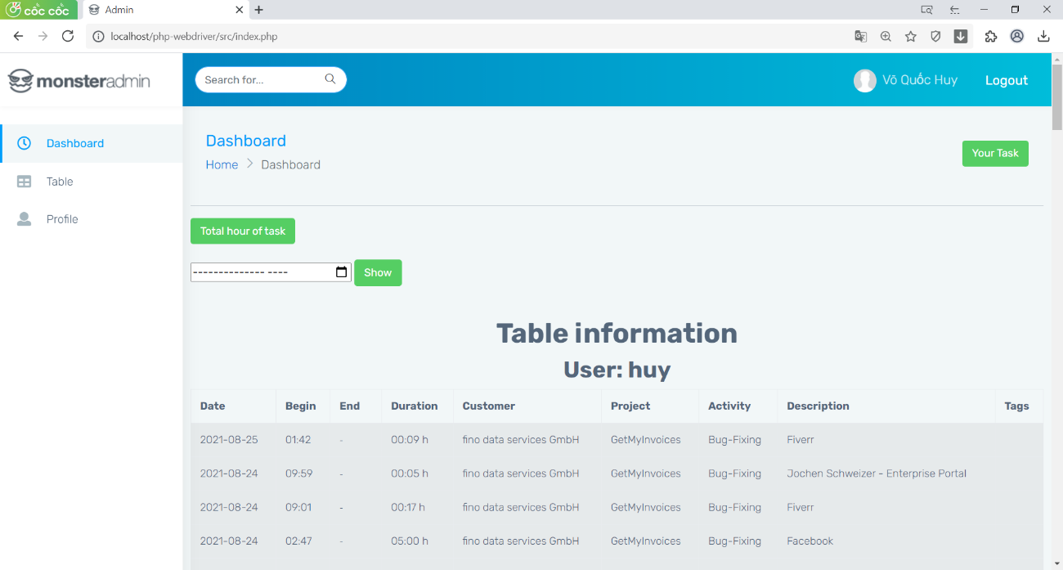Dashboard
    - Member manage

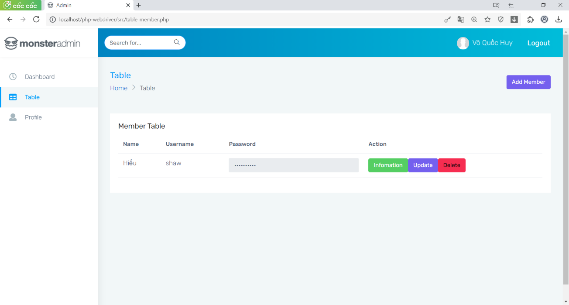

* + - 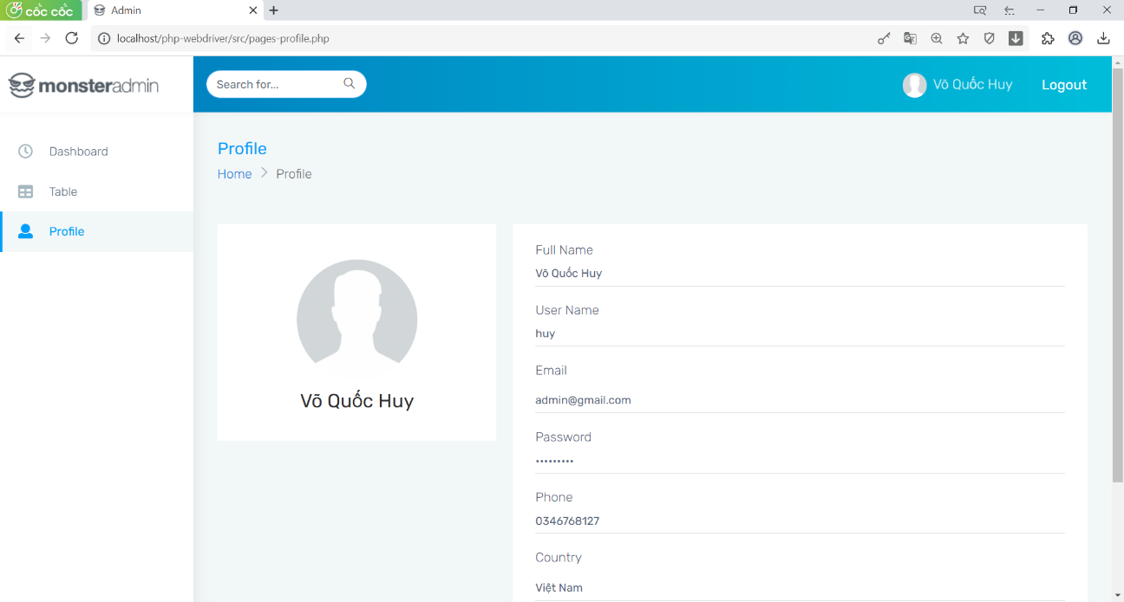Profile manage
  + Functions:
    - 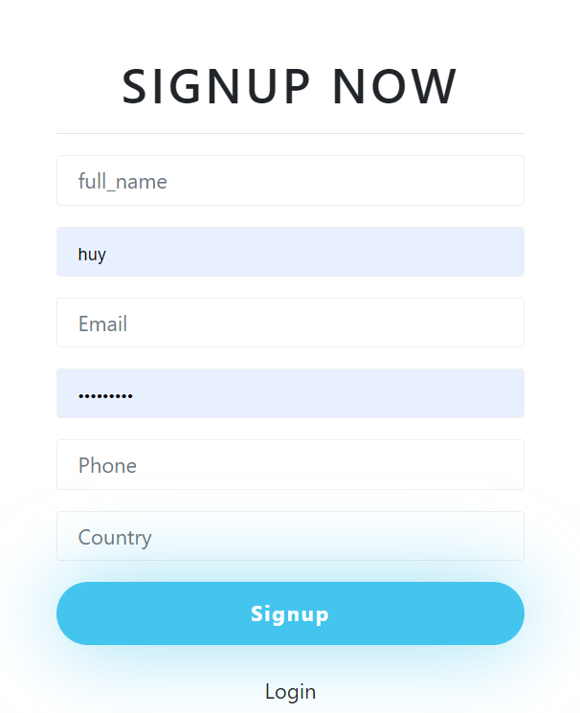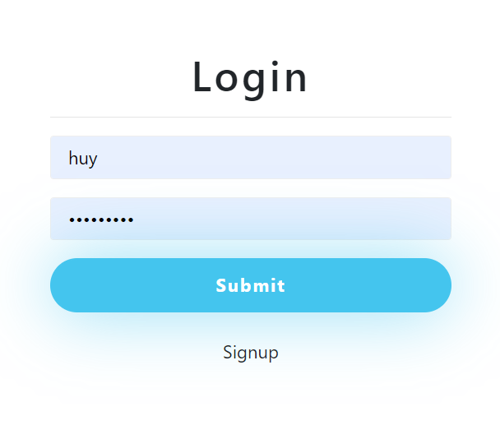Login / Sign up
    - 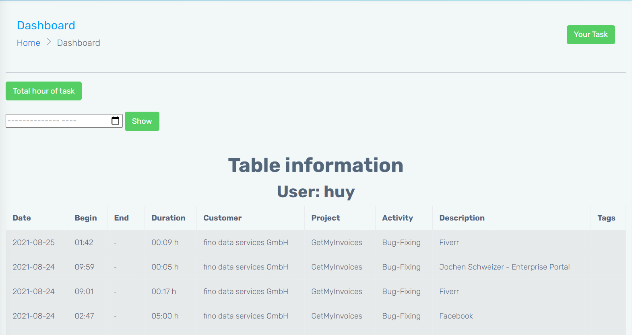Show all record of user or another member
    - 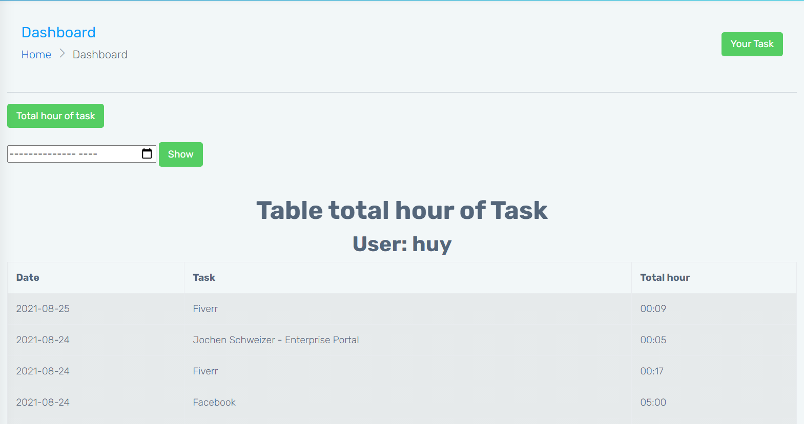Show total hour of task
    - 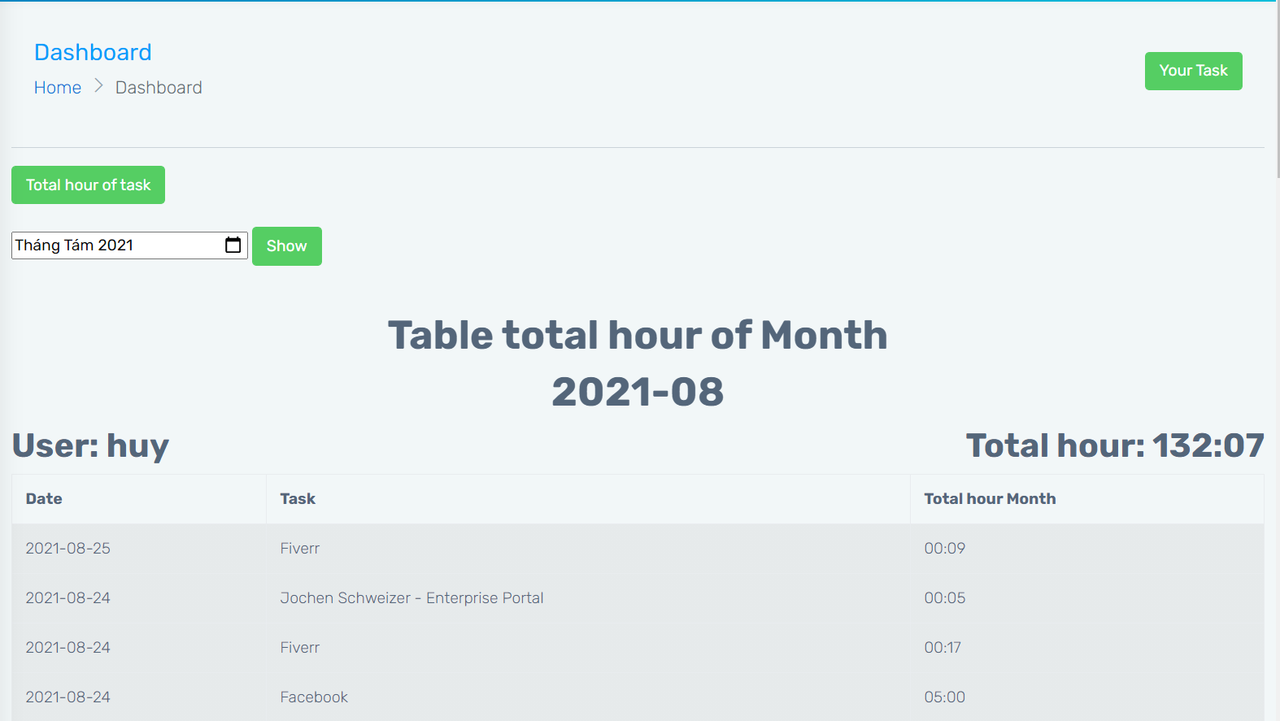Show total hour of month
    - 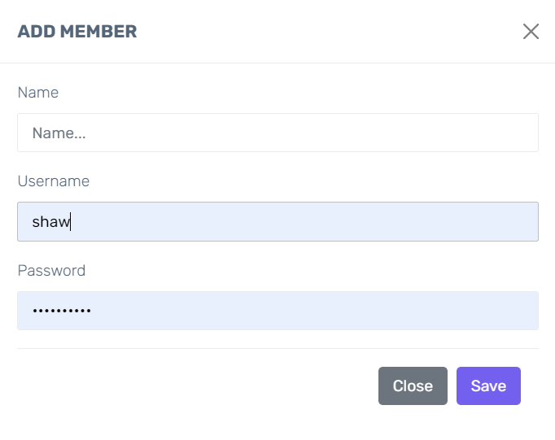Add member
    - Update member

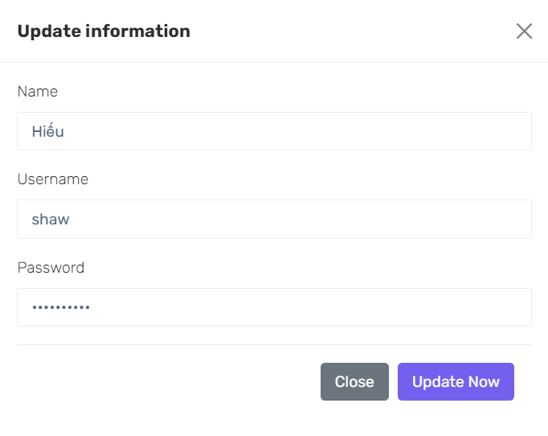

* + - Delete member
    - 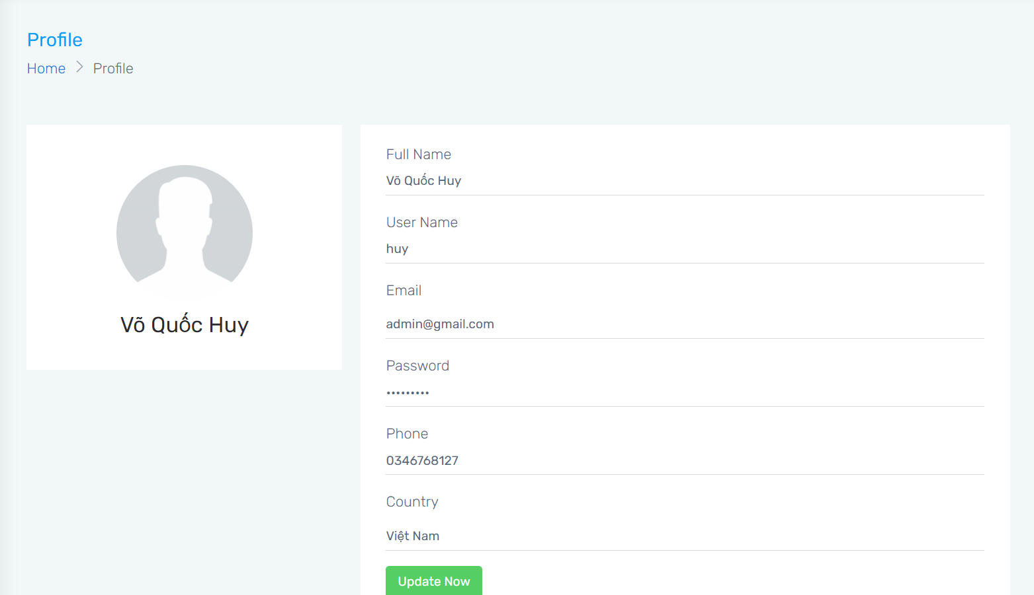Update information of user
* Detail about myself:
  + My role in the project: Team leader
  + My main tasks:
    - Receive tasks, analyze and divide tasks among members
    - Create functions show all record of user or another member, Show total hour of task, show total hour of month
    - Create file run webdriver

1. Working environment :
   1. Day to day work and analysis

* My daily work routine:
  + 8:45 am: Check messages and task on skype.
  + 9:00 am: Start working hours
  + 10:30 am: Break time
  + 10:45 am: Keep working
  + 12:00 pm: End of working hours
  + 13:20 pm: Check messages and task on skype.
  + 13:30 pm: Start working hours
  + 15:30 pm: Break time
  + 15:45 pm: Keep working
  + 16:30 pm: Writing report
  + 17:00 pm: End of working hours
* Did not understand the task assigned by the mentor:
  + Asking the mentor again at the time he assigns the task
  + After completing a task to confirm with the mentor for early adjustment.
* Tool documentation not available:
  + Searching for information in English
  + Posting questions and questions to groups about that tool
  + Learning through examples of other programming languages
* Self-study and do tasks that take a lot of time:
  + Breaking down the task into smaller tasks
  + Using some free time in the day to learn more about that knowledge.
  1. 02 Soft skill-related experiences
* Skill 1 : Reseach information
  + Search for information in English
  + Search a variety of media: videos, documents and ask people who know about it
  + Filter out ideas to note and compare with other trainee
* Skill 2 : Team work
  + After receiving the task, together analyze and separate the task into smaller tasks to make it easier and save more time.

1. Conclusions ( 3 pages max) Please describe in your own words:
   1. Achievements / successes :

* I had the opportunity to participate in a small project close to reality and did my best
* I had the opportunity to improve my communication skills through communicating with mentors and team members
  1. Conclusions / What I learned :
* The biggest lesson and also the first lesson that I learned when I went to practice was "being proactive". Proactively research information, proactively create professional working habits and proactively improve the results achieved
* I have reviewed some old knowledge about php and besides, I learned about Selenium and its application to the project I worked on during my last month of internship
  1. Career path impact / How will this experience affect my future?
* During my internship, I was able to apply the knowledge I learned and see my own flaws so that I could continue to improve. At the same time, with the help of experienced people at the internship site, I have learned lessons to avoid mistakes in the future practice.

Comments/Evaluation of mentor at PNV: (attach with this report)